What is Special Education?
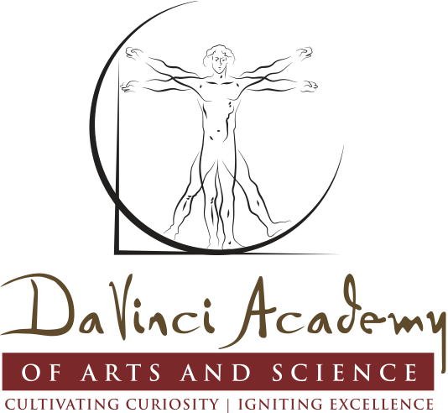

DaVinci Academy of Arts & Science
13001 Highway 65 Northeast
Blaine, Minnesota 55434
(763) 754-6577
www.davincicharterschool.org

This brochure is meant to provide information for parents/families regarding the school-based service called “Special Education.”

What is Special Education?

“Special Education” is instruction, specific to the child, at no cost to parents, to meet the unique needs of a child with a disability. It is important to note: students with disabilities are general education students first. They receive special education support services in conjunction with the general education curriculum. Special education is an instructional service, not a place. Special education services must be reasonably calculated to allow the student to benefit from instruction. If the student is receiving benefit from the special education services, the student will progress at his/her own individual rate. A student who has a disability will always have the disability and would not be expected to progress in all areas at the same rate as his/her general education peers.

What is a Disability?

A disability is a lifelong handicapping condition often associated with a physical or mental impairment that substantially limits a major life activity – including education.

Who can receive Special Education Services?

To qualify for special education services a child must have a disability. The child must meet State eligibility criteria in one or more of the following areas:
- Autism Spectrum Disorder
- Blind or Visually Impaired
- Deaf and Blind
- Deaf and Hard of Hearing
- Developmental Adaptive Physical Education
- Developmental Cognitive Disability
- Developmental Delay (ages birth through 5)
- Emotional or Behavioral Disorders
- Other Health Disabilities
- Physically Impaired
- Severe Multiple Impairments
- Specific Learning Disability
- Speech Language Impairment
- Traumatic Brain Injury
An evaluation is used to document the existence of a disability. Below average academic performance alone does not qualify a student for Special Education.

How does a child receive Special Education Services?

The school will conduct an evaluation to determine your child’s area of need (such as reading, math, and written language). With your input, goals will be written to improve the areas of need identified. These goals will be written on a document called an Individual Education Program (IEP)/Interagency Individual Intervention Plan (IIIP). Specialized instruction may be provided in the areas of need. Special education areas of need may include:
* Reading * Self-help Skills *Communication
* Writing * Motor Skills *Organizational Skills
* Math Skills *Transition Skills * Social Skills
* Related Services **

**Related services such as occupational therapy, physical therapy, DAPE, etc., are provided if it is determined the child would not be able to meet their instructional goals without this service. Related services cannot be provided unless the student is already receiving a special education service in a disability area, such as a learning disability. The related service is only provided if the student requires the service in order to make progress on IEP/IIIP goals.

What should you expect if your child receives Special Education Services?

Parents should expect to participate as a team member in decisions regarding their child’s special education program. Your child should receive instruction that has been individualized to meet the specific needs of your child. Special education instructors will work with regular education teachers to provide the appropriate accommodations and modifications within the regular education setting. Modifications and accommodations can include such things as highlighted textbooks, shortened assignments, class notes, as well as other aids to assist students to succeed in school.

What Special Education is NOT

- Tutoring in regular education courses.
- An assurance that students will pass regular classes.
- Special education is not a cure. It assists in removing barriers caused by the disability but does not remove the disability.
- Rehabilitation for a physical disability.

